Parts of a Chemical Equation

Introduction
When elements or compounds react to form something new, it is called a chemical reaction. We write chemical equations to show exactly what is happens when the reaction occurs. This is a sample chemical equation that shows what happens when glucose (sugar) burns:

C₆H₁₂O_{6(s)} + 9O_{2(g) →} 6CO_{2(g)} + 6H₂O_{(l)}

The starting materials in a reaction are called the reactants. The elements or compounds that are formed as a result of the reaction are called products.

What are the two reactants in this equation? __________________ __________________

What are the two products in this equation? __________________ __________________

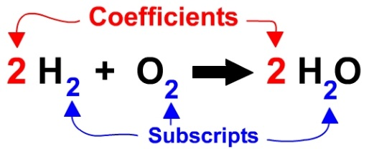
The smaller numbers after some of the elements are called subscripts. These tell you how many atoms of that element are present in the compound. The larger numbers that come before some of the compounds and elements are called coefficients. These tell you how many of that specific molecule were reacted or produced in the equation.

How many carbon atoms are present in sugar? ______________

How many hydrogen atoms are present in water? ______________

How many molecules of oxygen were reacted when the sugar was burned? _____________

How many molecules of carbon dioxide gas were released by the reaction? ____________

The letters in parenthesis after each element or compound tells what state of matter it is in.
(s) indicates a solid.
(l) indicates a liquid.
(g) indicates a gas.
(aq) indicates an aqueous solution – something that is dissolved in water.

What substance(s) in the sugar reaction were solid?

What substance(s) in the sugar reaction were liquid?

What substance(s) in the sugar reaction were gas?

Diatomic Elements
When writing an equation, it is important to remember that some elements do not exist alone, but they pair up with other atoms of the same element. These are called diatomic elements. These are:

Hydrogen (H₂)
Oxygen (O₂)
Nitrogen (N₂) Remember these with the acronym:
Chlorine (Cl₂) “HONCl BrIF”
Bromine (Br₂)
Iodine (I₂)
Fluorine (F₂)

There are two other nonmetals you should remember too:
Sulfur (S₈)
Phosphorus (P₄)

Practice
Write an equation for each of the described reactions. Include subscripts, and state of matter notation as needed. Don’t forget about the diatomic elements!

- Solid lithium reacts with water to produce hydrogen gas and a solution of lithium hydroxide.

- Solid sodium reacts with gaseous chlorine to produce sodium chloride.

- Solid calcium carbonate breaks down into carbon dioxide gas, oxygen gas, and solid calcium.

- Solid iron(II) sulfate and a solution of barium chloride react to form solid barium sulfate and a solution of iron (II) chloride.

- Solutions of hydrochloric acid and sodium hydroxide react to produce liquid water with sodium chloride dissolved in it.

